DiVE Manual

# How to perform experiment

1. Run the DiVE server
   1. Run the photon server with administrator privilege, click C:\Users\admin\Desktop\DiVE3D\DIVE_Server_BK\DiVE\bin_Win64\PhotnControl.exe
   2. If the server successes to run, an icon with blue circle would be shown on the icon list. If the service is failed to launch, the circle would be twinkling or just gray. 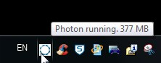
2. Run the DiVE TestBed Server
   1. Run the DiVE Testbed server at C:\Users\admin\Desktop\DiVE3D\dive_testBed\DiVE Testbed Server\bin\Release\DiVE Testbed Server.exe
   2. A console would then showed up.

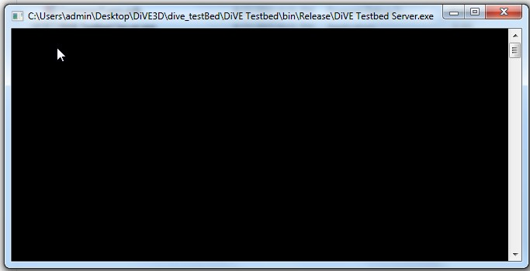

* These two servers should be running on the same Computer.

1. Run the testbed client
   1. Run the DiVE Testbed at C:\Users\admin\Desktop\DiVE3D\dive_testBed\DiVE Testbed Server\bin\Release\DiVE Testbed.exe

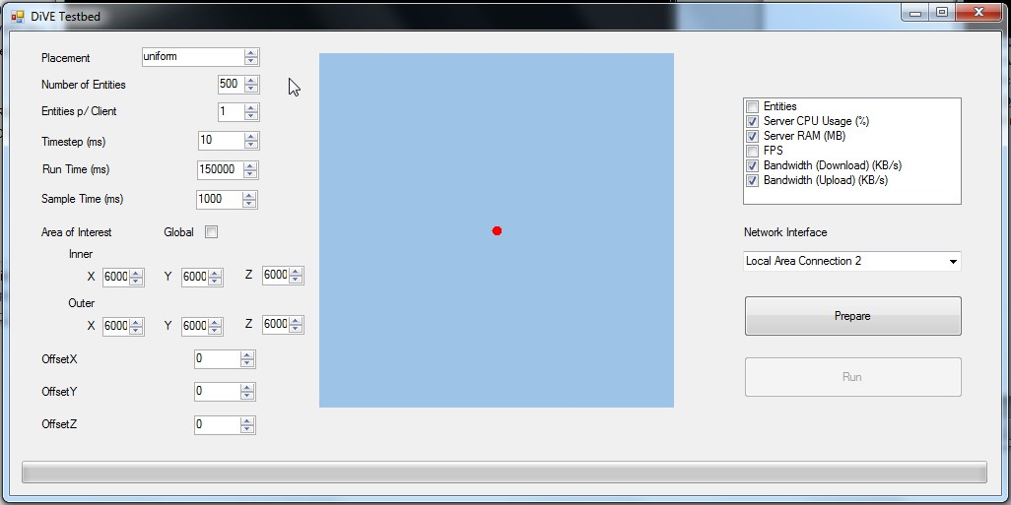

* 1. The input parameters could be changed using the control panel on the left hand side.

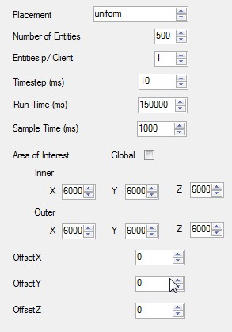

* + 1. Placement: No effect.
    2. Number of entities: from 1 up to 10000, but on experiments if the number of entities went beyond 800, it would have problems like crash with lack of memories or failed at collecting sample data.
    3. Entities p/ Client: Could simulate multiple clients on one machine, but we could use multiple virtual machine run this client distributive. So better not to change here.
    4. Timestep (ms): minimum 10, no need to change.
    5. Run Time (ms): Decide how long you want to run the simulation, default is 150 seconds.
    6. Sample time (ms): how frequent to sample the data.
    7. Area Of interest: If the checkbox is checked, it would apply no interest management, The Inner and Outer could be varied independently.
    8. OffsetX, OffsetY, OffsetZ: not used
  1. The checkbox on the right hand size could control which kind of data you want to sample
     1. 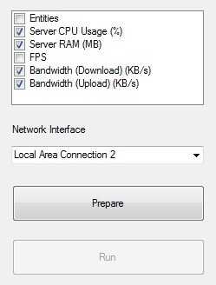
     2. The default setting is shown before, we have majorly interest on Server CPU Usage, Server RAM and Bandwidth. These data are collected via Testbed server running on the server side.
     3. Network Interface: you may choose which internet interface you want to sample.
  2. If the setting is finished, click “Prepare” , you would see the green progress bar running, don’t click it twice in one trial, it would be failed and consume lots of resource.
     1. 
  3. When the progress bar finished, click the “Run” button
  4. A monitoring window would showed up, in order to lessen the load of client, only small portion is showed.
     1. 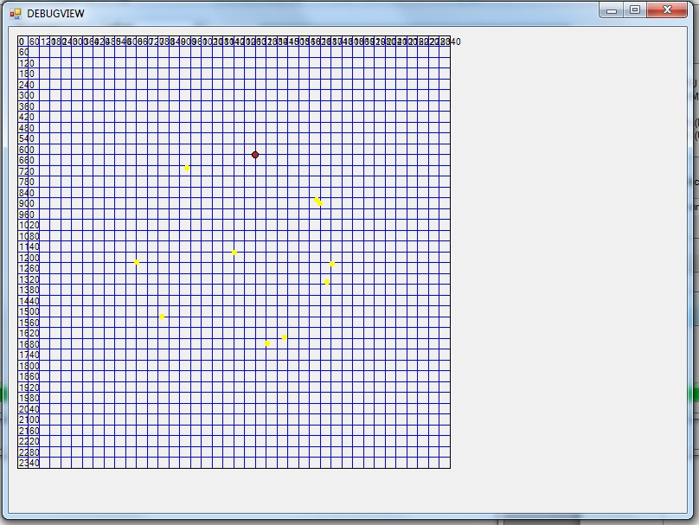
  5. When the simulation is done, the result of sampling data would show up.
     1. 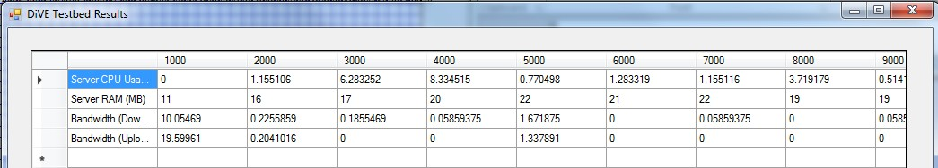

1. Run the testbed Client on Virtual machine
   1. Use the mac to connect to virtual machines, there are 8 machines in total.
      1. The application for running the remote is “Remote Desktop Connection”
      2. Addresses are: hvm02-08-0x.gloabllabproject.net (n=0~8).
      3. Before connect to the virtual machine, ask Pascal for an account.
         1. Domain: globallabproject.net
      4. The Testbed client is located in “C:\Users\Public”

# How to modify the settings via code

1. Change the size of the world.
   1. C:\Users\admin\Desktop\DiVE3D\DIVE_Server_BK\DiVE\Server\ExSpace.DiVE.Server.dll.config
   2. <world name="TheDrone" bottomRightCornerX="240000" bottomRightCornerY="240000" bottomRightCornerZ="18000" tileDimensionsX="6000" tileDimensionsY="6000" tileDimensionsZ="6000" topLeftCornerX="0" topLeftCornerY="0" topLeftCornerZ="0"/>
2. Change the IP address of DiVE Testbed Server which DiVE Testbed is connecting to
   1. In the same folder which you have the file “DiVE Testbed.exe”, there is a file called “DiVE Testbed.exe.config”
   2. At line 67,

<setting name="DiVE_Location" serializeAs="String"><value>136.187.100.97:443</value></setting>

* 1. Change the ip address to the computer you run the DiVE Testbed Server.